**Azure Storage Account Creation And Establishing Connection With Azure Storage Explorer**

**Name**: Priyeshwar

**Mail**: [priyesh2664@gmail.com](mailto:priyesh2664@gmail.com)

Open the Azure Dashboard

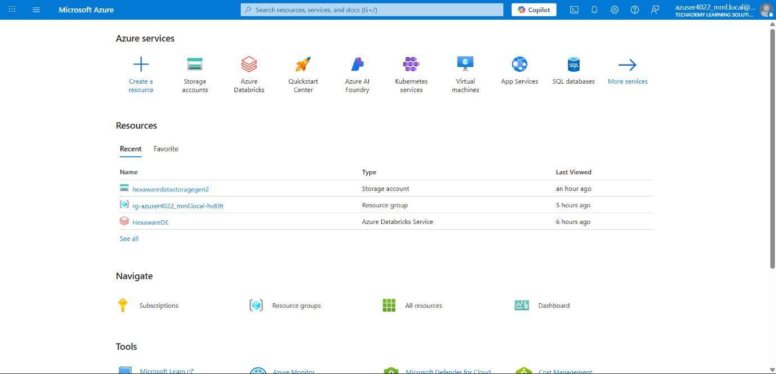

In Search bar, search storage accounts

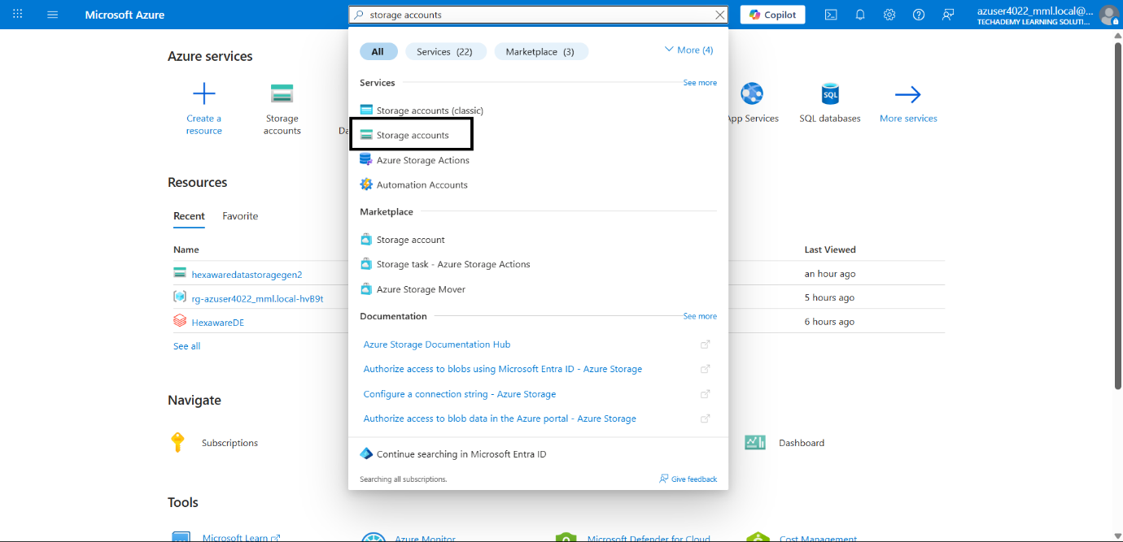

In storage account page, click create

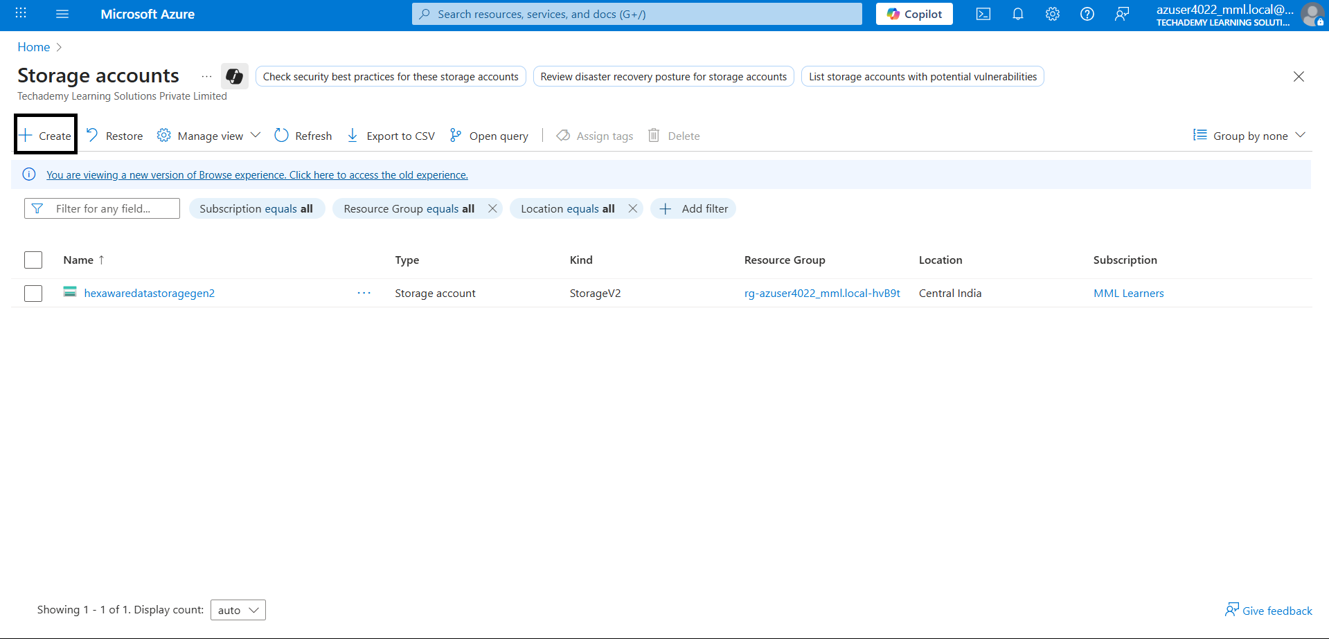

Set the configuration for the account creation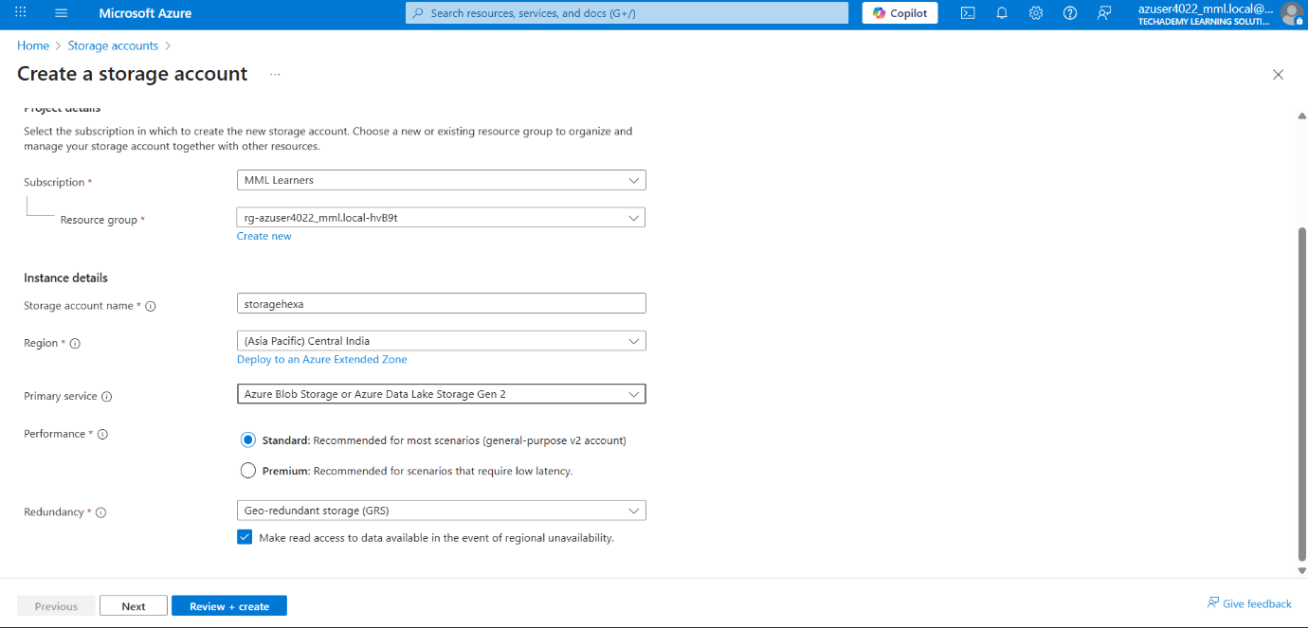

Enable the Hierarchical Namespace for Enabling Data Lake Storage

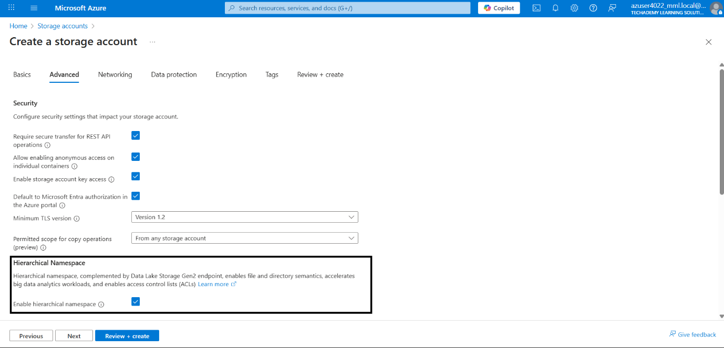

Click review and create

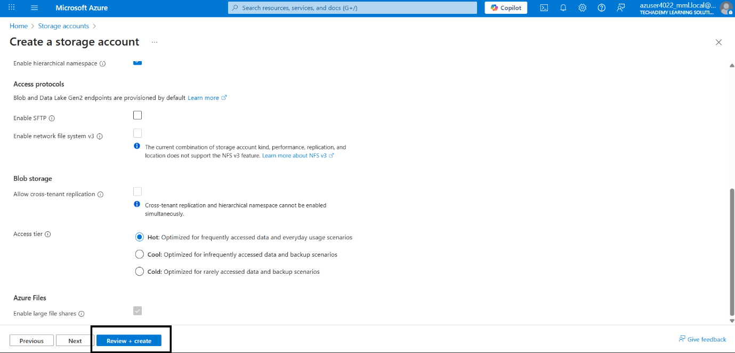

After the storage account creation, goto containers

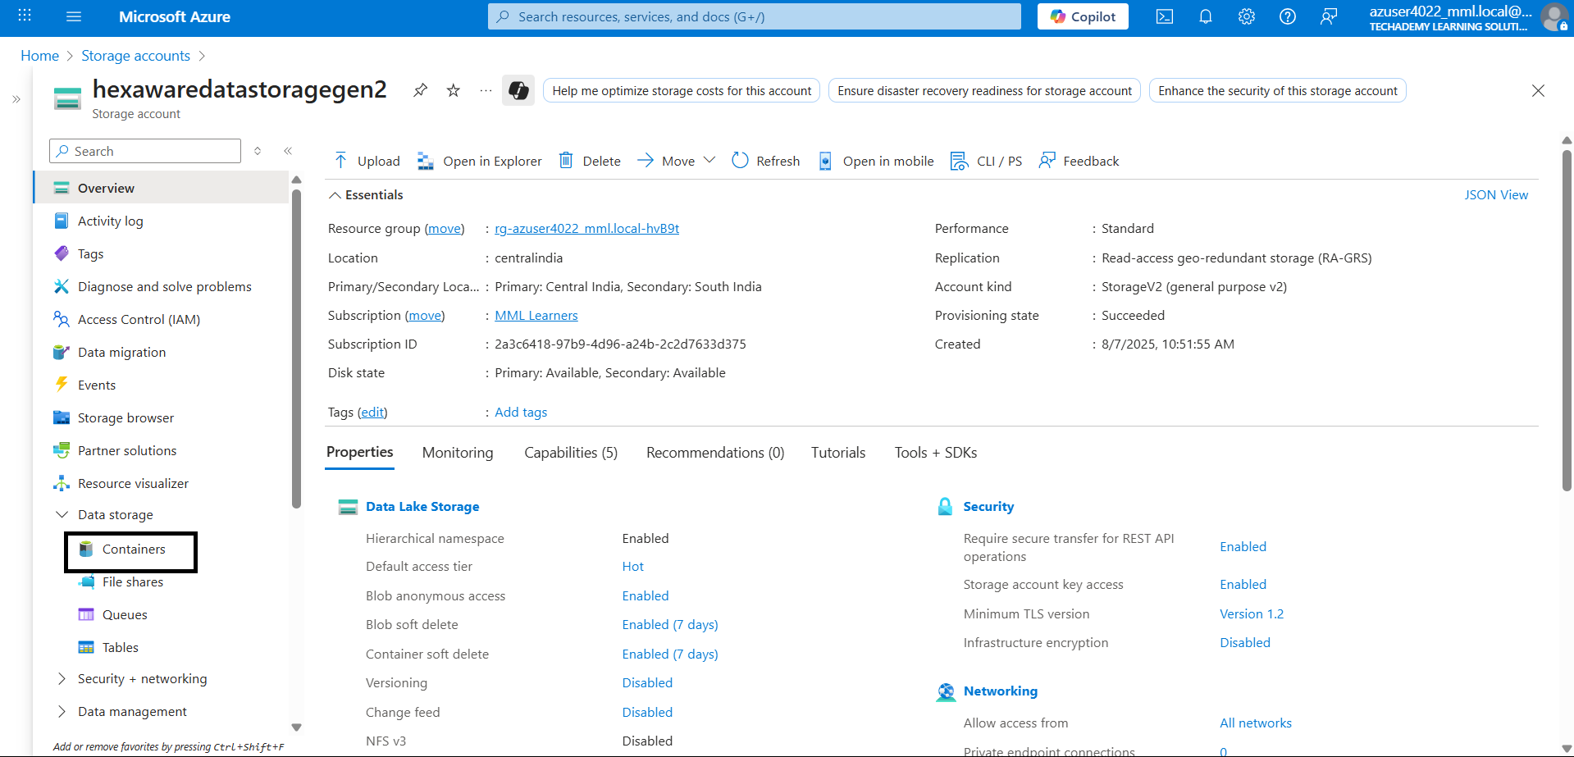

In containers, click add container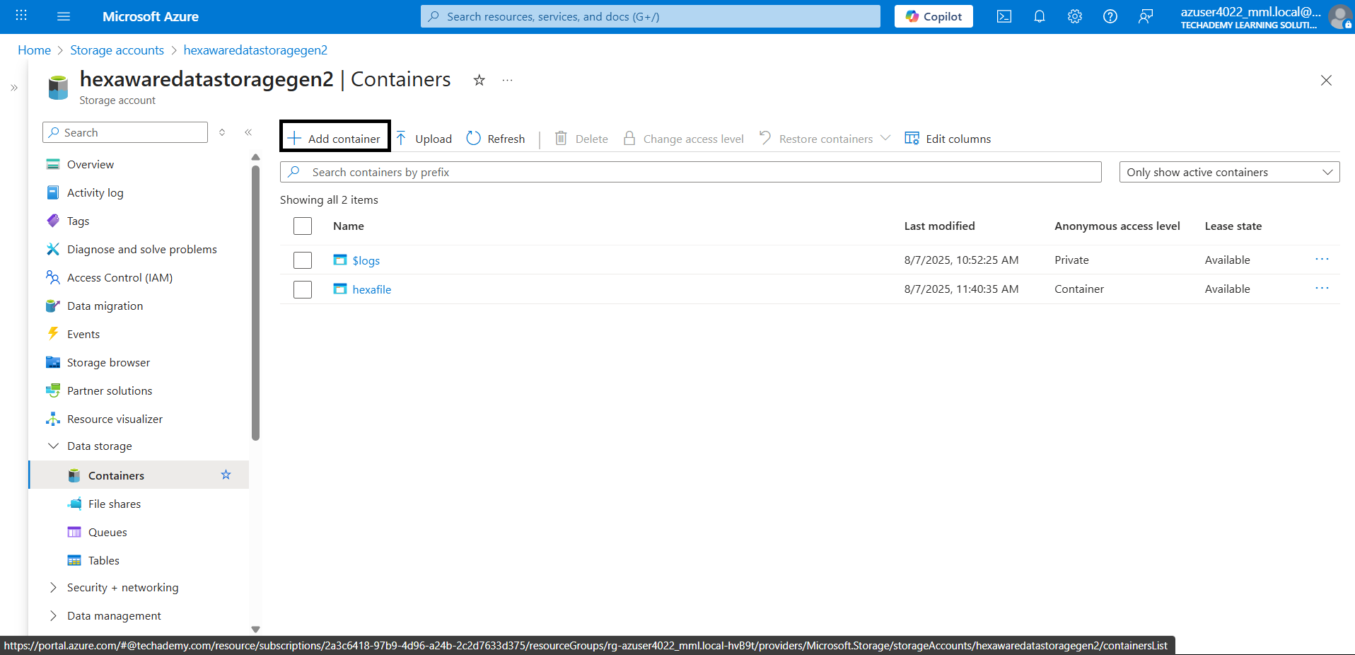

Set the configuration and click create

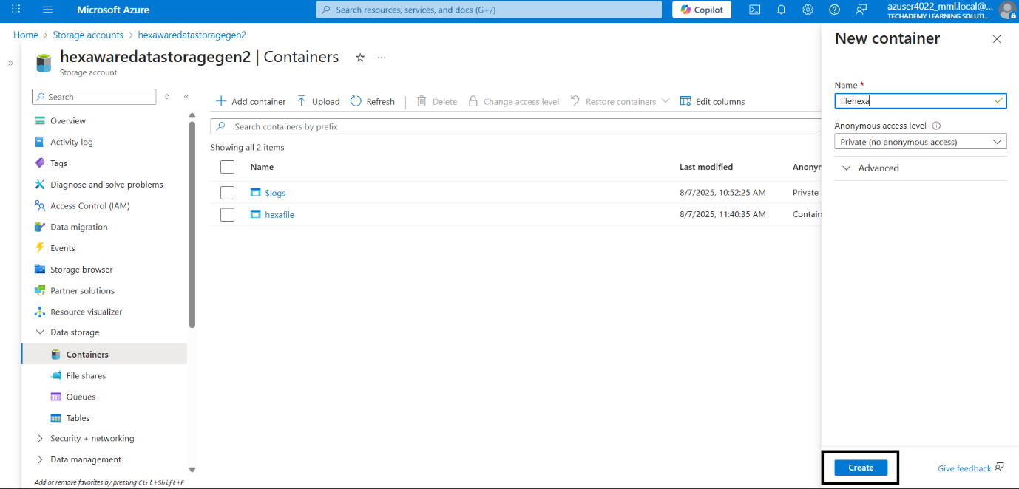

In the meantime, download Azure Storage Explorer  
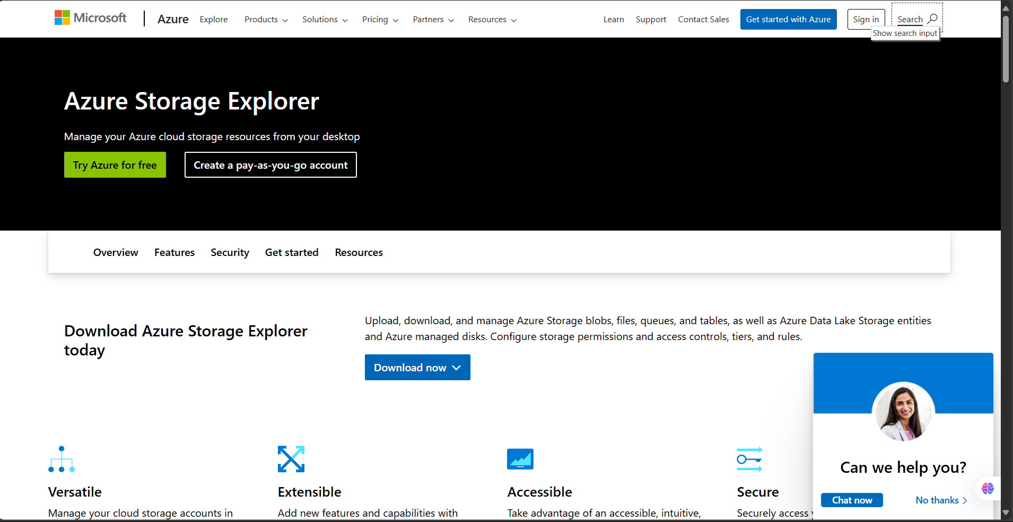

After the download, sign in with your Azure account. After that click attach to a resource

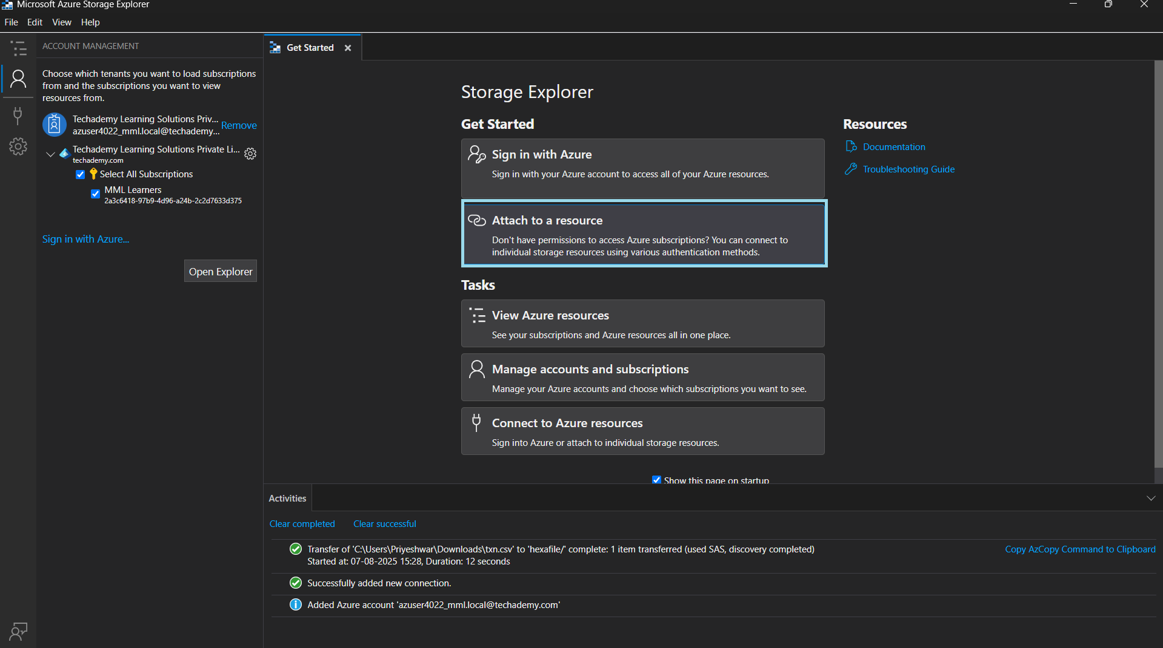

Click ADL Gen2 container or directory

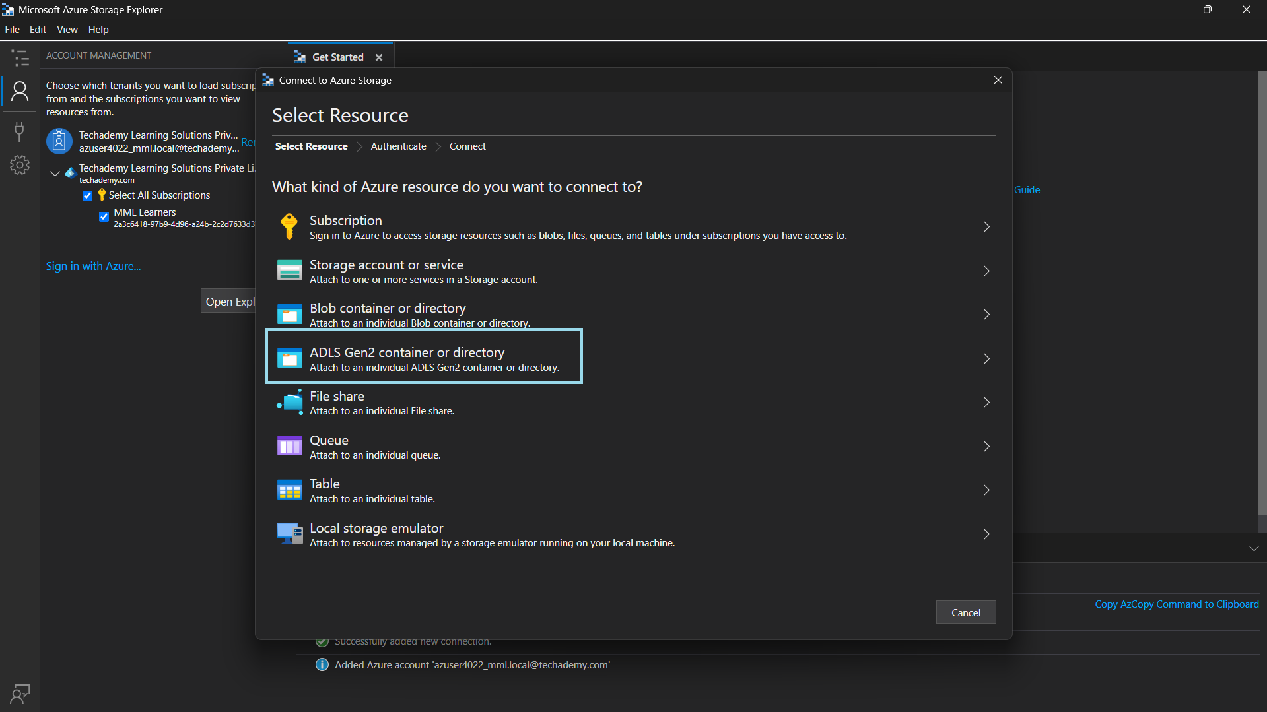

Click the shared access signature URL (SAS)

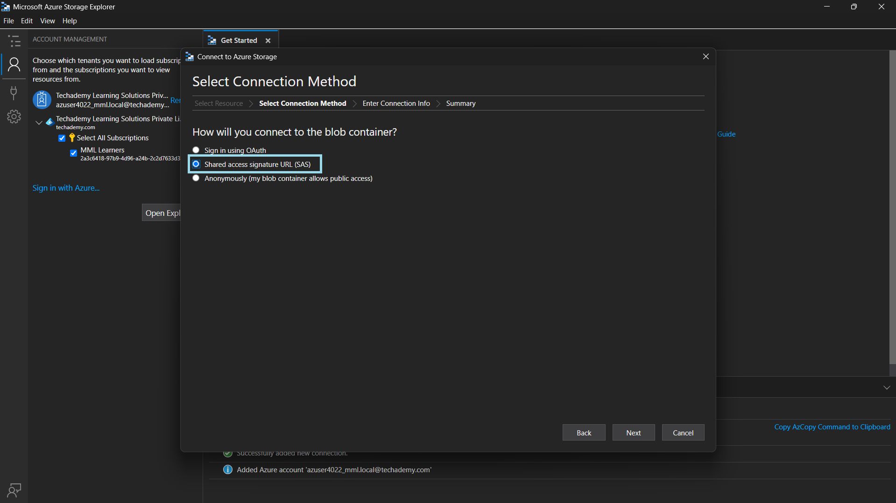

After that, you need the SAS URL

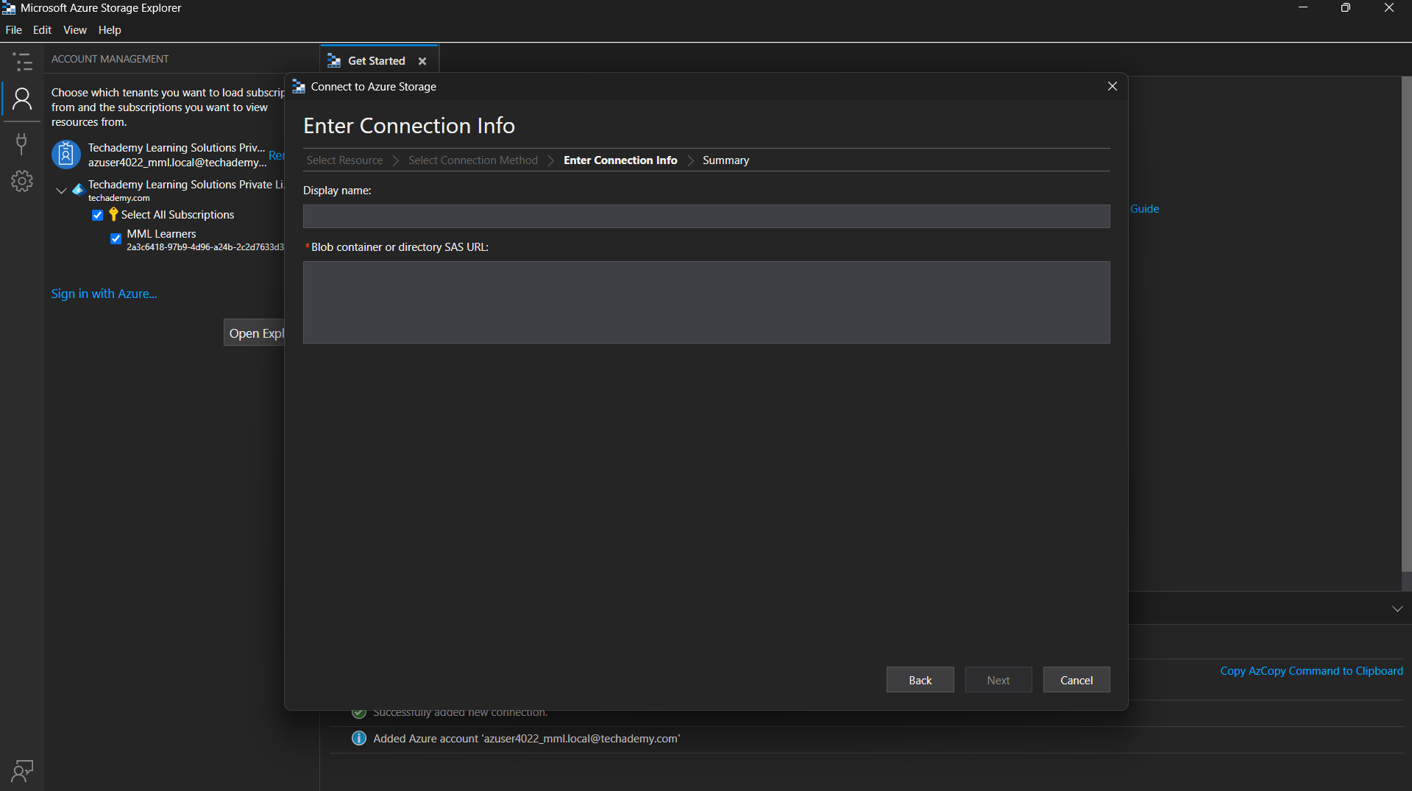

For the URL, go to containers in the storage account. Click the container

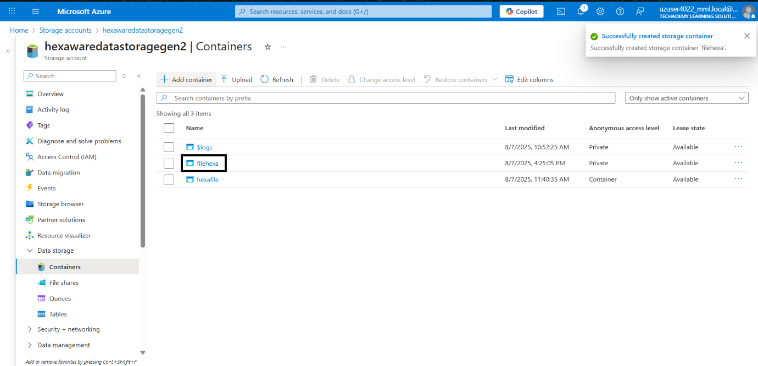

Click the shared access tokens

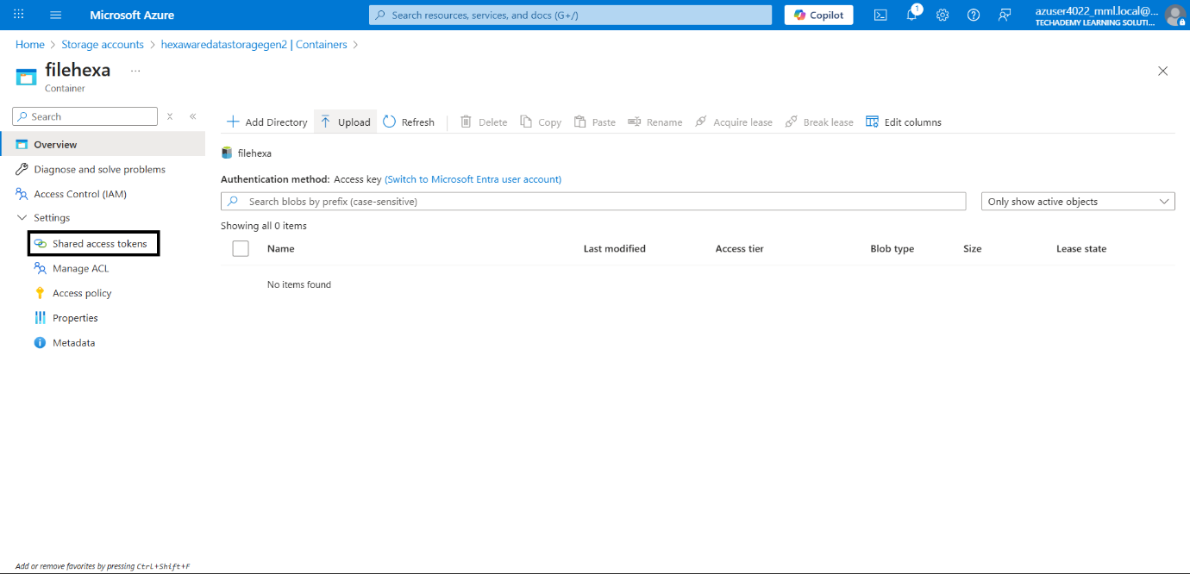

Select all the permissions

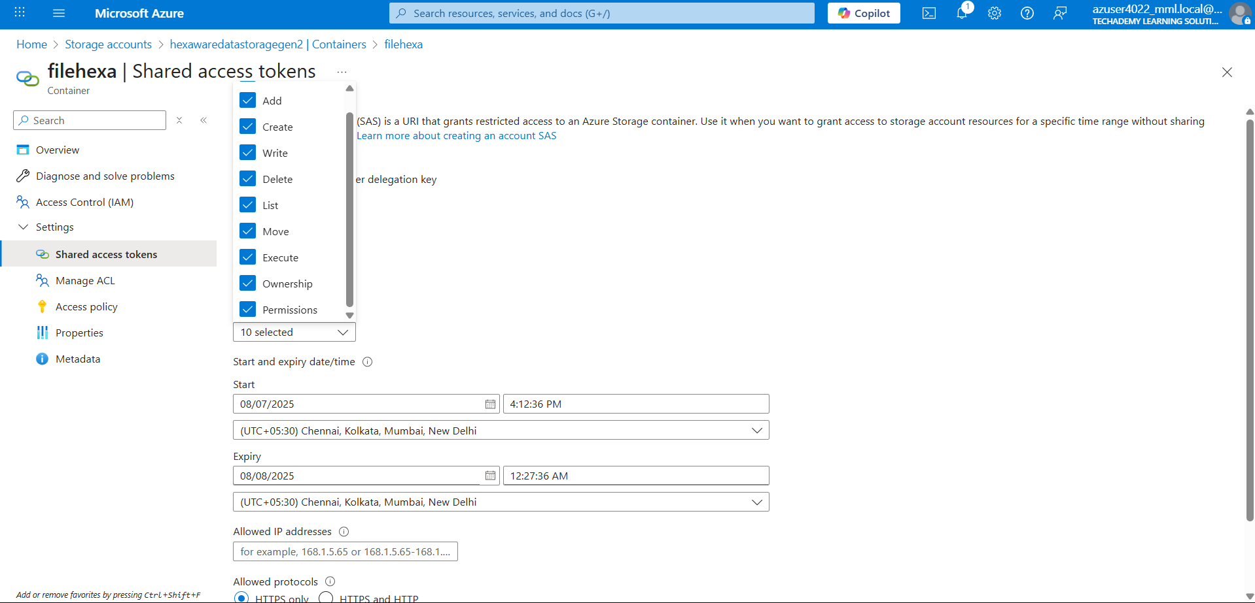

Click generate SAS token and URL

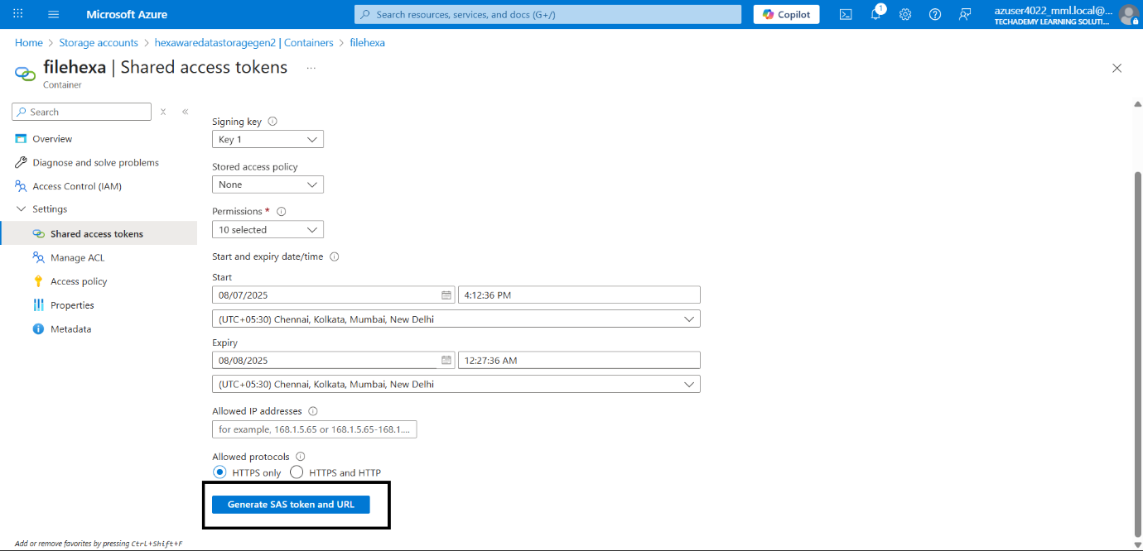

Copy the SAS URL

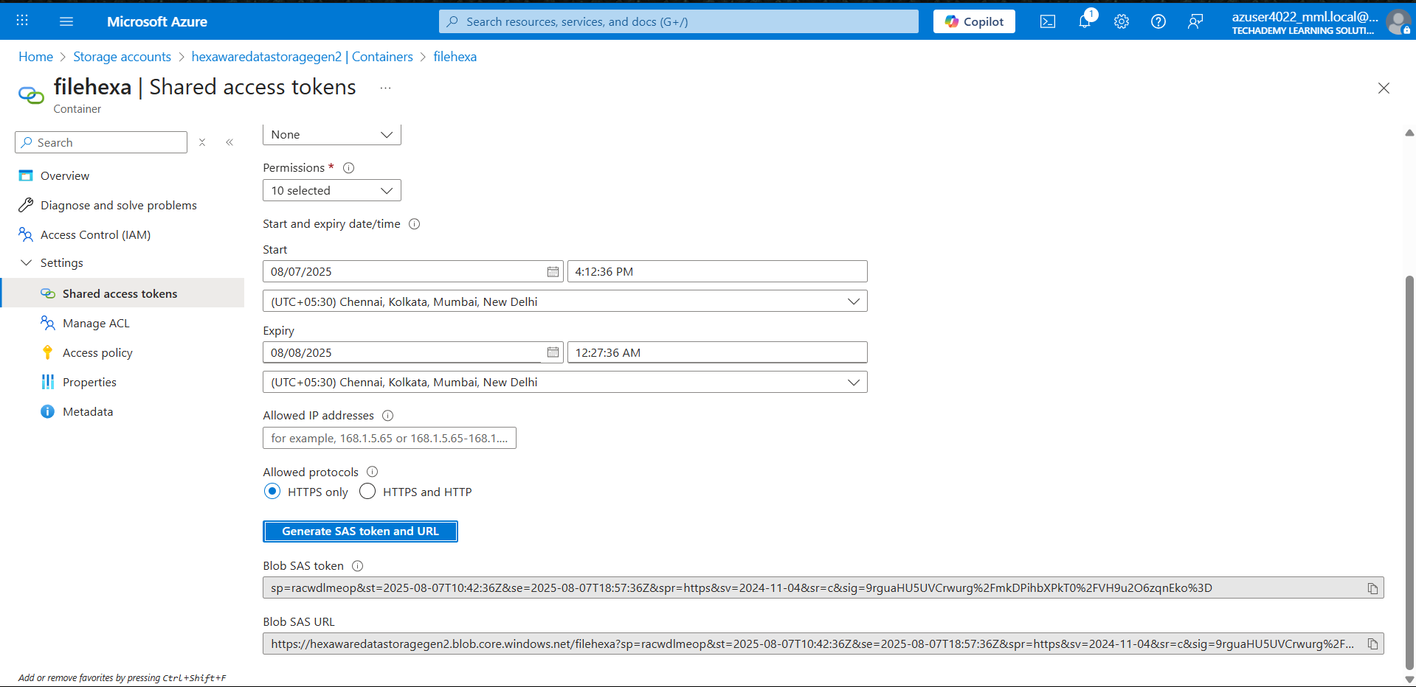

Paste the URL in the Azure data storage explorer

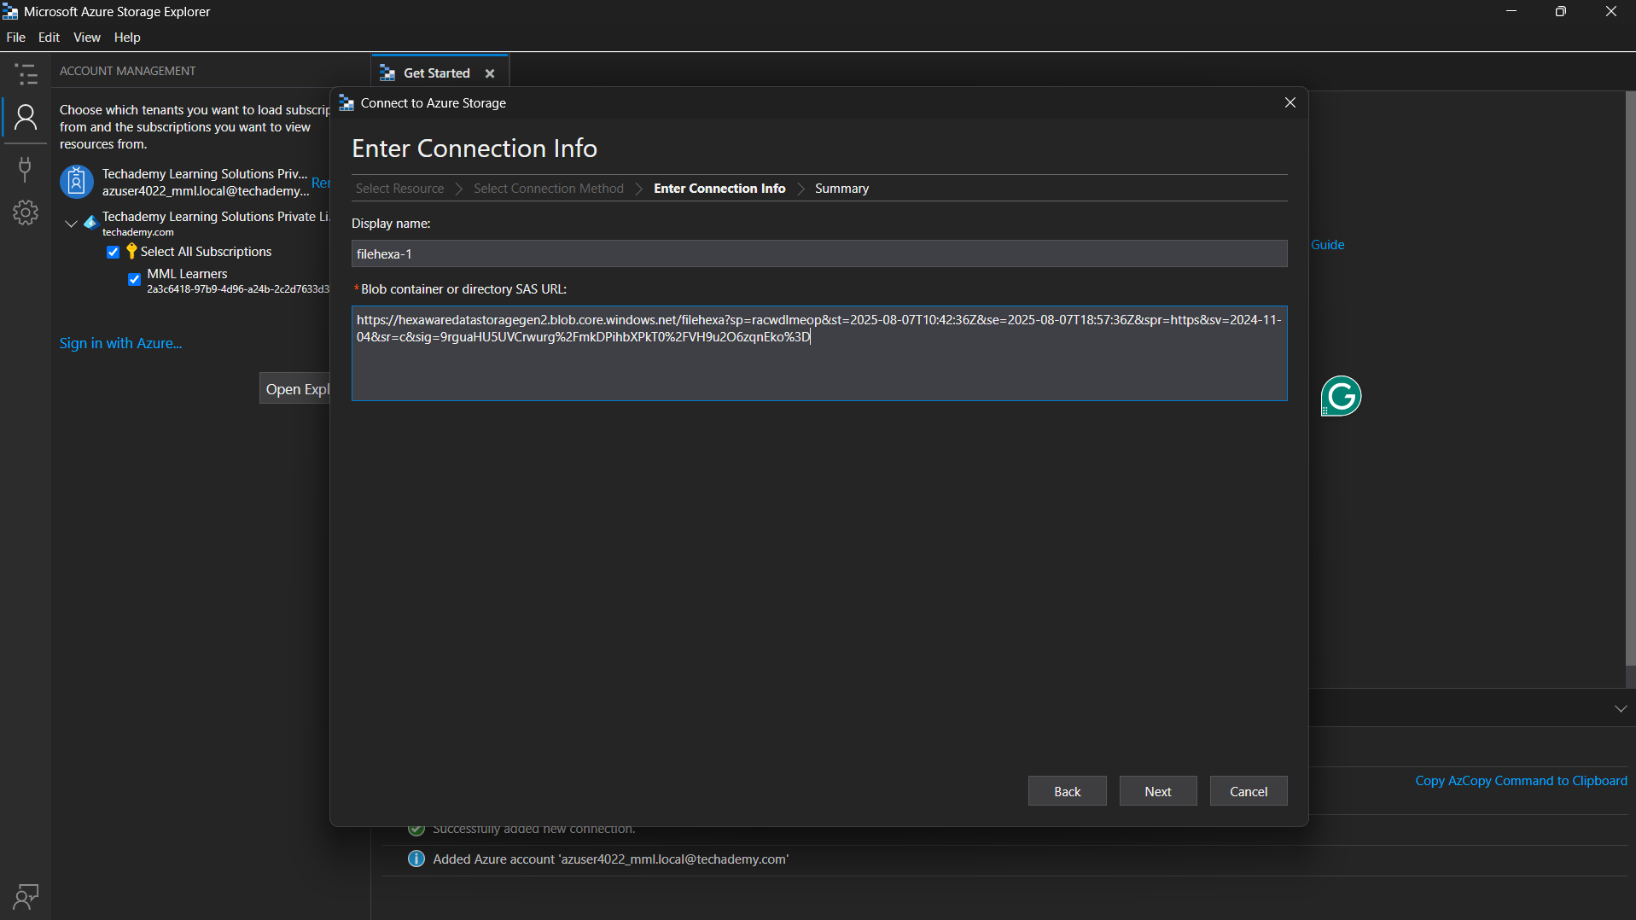

Click Connect to establish the connection

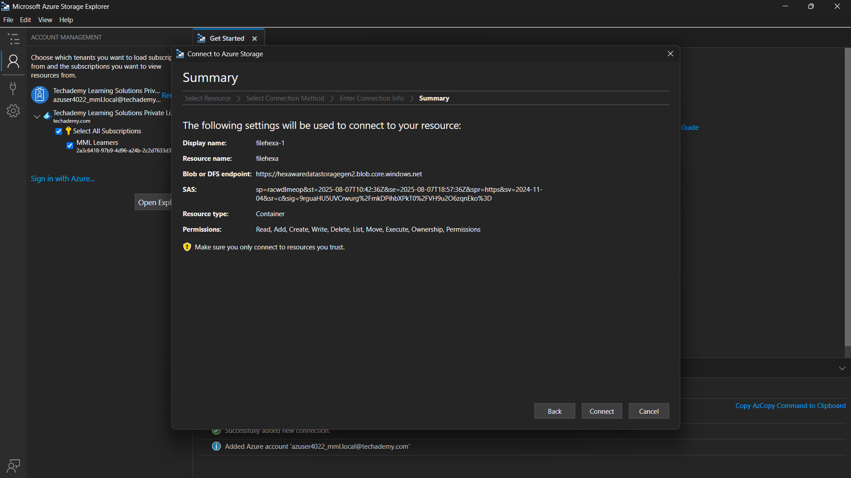

Azure storage explorer connected to the storage account successfully

